**Shouzab khan.**

**Skhan6**

**Full Disk Encryption**

**1. Detailed steps, including screenshots, for your experiments to turn on device encryption for your smartphone.**

First of all, we will go to our smartphone settings. Then click on your picture, then iCloud, then scroll down to the Advanced Data Protection option and turn it on. After completing all the steps for turning the encryption on your smartphone, go to “FaceID &Passcode.” Put your Passcode. Scroll down to where it will be written: “Data Protection Is Enabled.” It means that encryption on your smartwatch is on.

**Screenshot:**

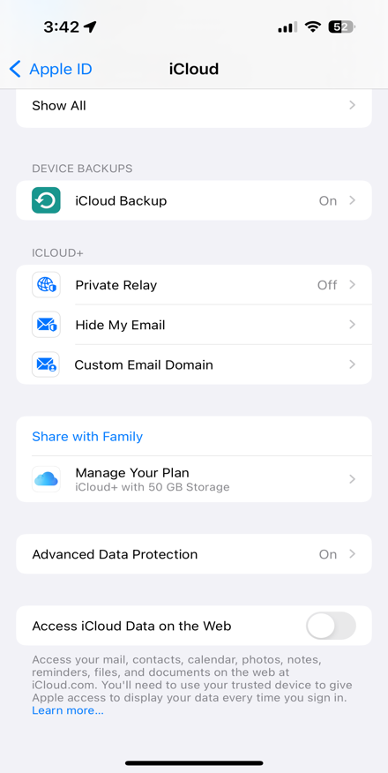 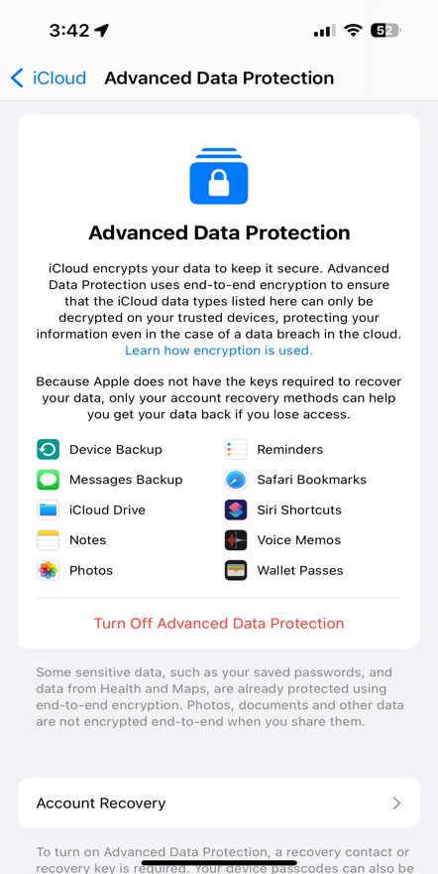 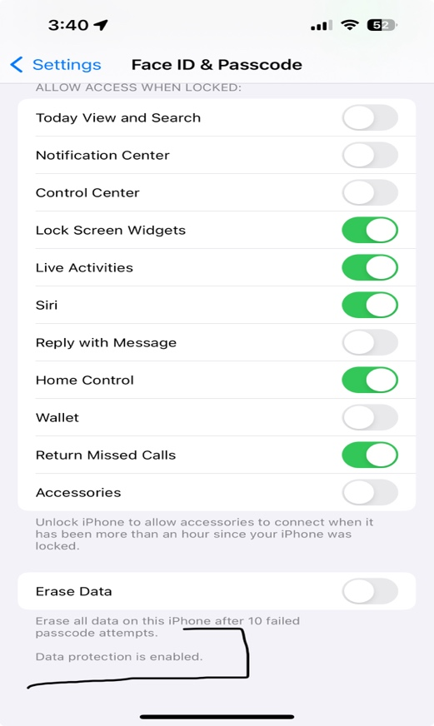

The first screenshot shows that the Advanced Data Protection on my Smartphone is turned ON.

Along with this the Second Screenshot Shows what what are the Application which will be using the Data Protection Encryption.

And the Third Screenshot shows that “Data Protection in Enabled” in the Face ID & Passcode Section.

**2. Detailed steps, including screenshots, for your experiments to turn on the native full disk encryption for your computer.**

To turn On the Native Full Disk Encryption on Mac, you have to turn on the FileVault in the Mac settings.

To Turn on the FileVault, you have to open the settings, then scroll down and look for “Privacy and Security.” Click on Privacy & Security” and scroll down to find “FileVault.” And turn on the FileVault.

**Screenshots:**

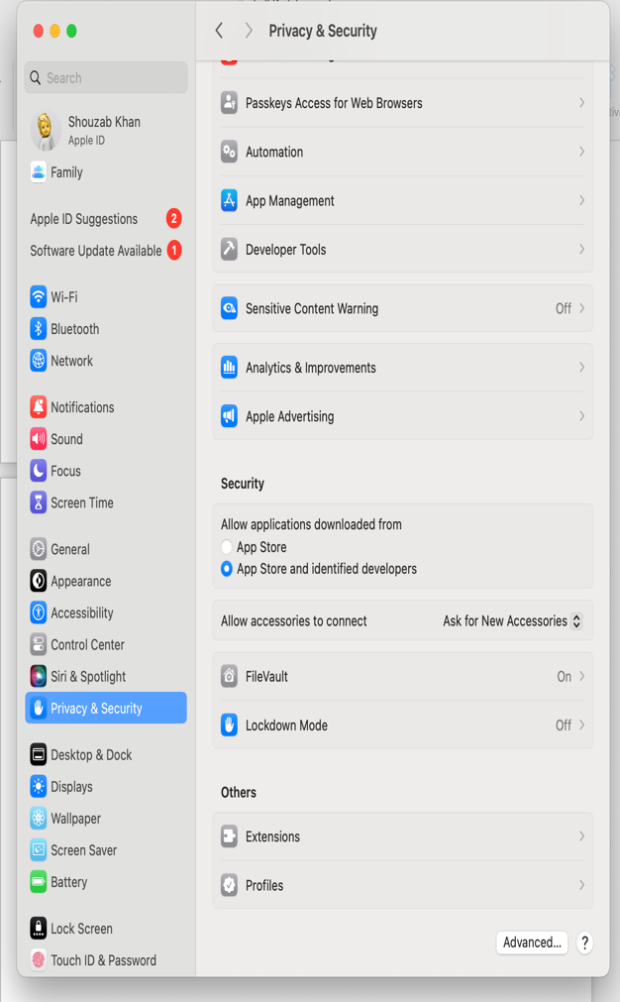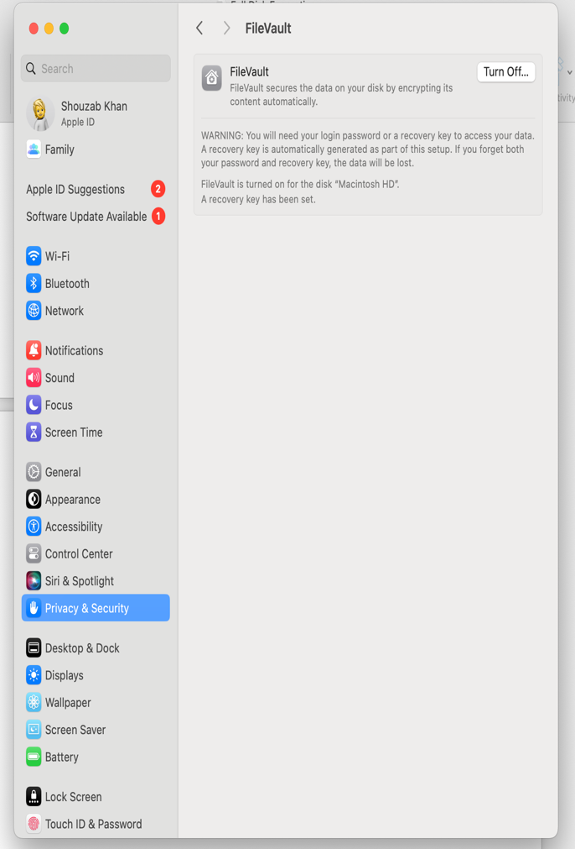

The First Screenshot Shows the “Setting” in which we have to look for “Privacy & Security.”

In the Second Screenshot, we have to find the FileVault and turn it on.

And it can be seen that it's turned on!!

**3. A comparison of the native full disk encryption of your computer and VeraCrypt.**

I have used both of them, so the comparison between VeraCrypt and FileVault is that:

1. FileVault is easy to use. It is User friendly. It is also fast, as there are just a few steps, and your USD drive is encrypted. But for VeraCrypt, we have to download it first, and also, there are a lot of steps to perform to encrypt the drive.
2. FileVault is just for MAC OS, but the VeraCrypt can be Used for Any OS. The container can be accessible on any OS.
3. The FileVault doesn’t give options for encryption algorithms and hash function customization, but the VeraCrypt does give this option to their users.
4. FileVault is better in terms of performance, maybe it's because of the OS compatibility. But the VeraCrypt performance depends on the Encryption Algorithm and hash function.
5. The FileVault is just for MAC OS, so it's more secure as compared to VeraCrypt because it’s Open Source.
6. If the FileVault user forgets the password, so, iCloud can back up the password, but as for the VeraCrypt, there will be no chance to back up the password if the user forgot the password.

**4. Detailed steps, including screenshots, for your experiments to encrypt the contents on a USB drive or an SD card using the native full disk encryption of your computer.**

Encrypt the USB drive using the native full disk encryption of the computer, which is FileVault. First, we have to connect the USB drive to our computer. After that, we have to open the Disk Utility in the finder -> Applications.

It will be like this:

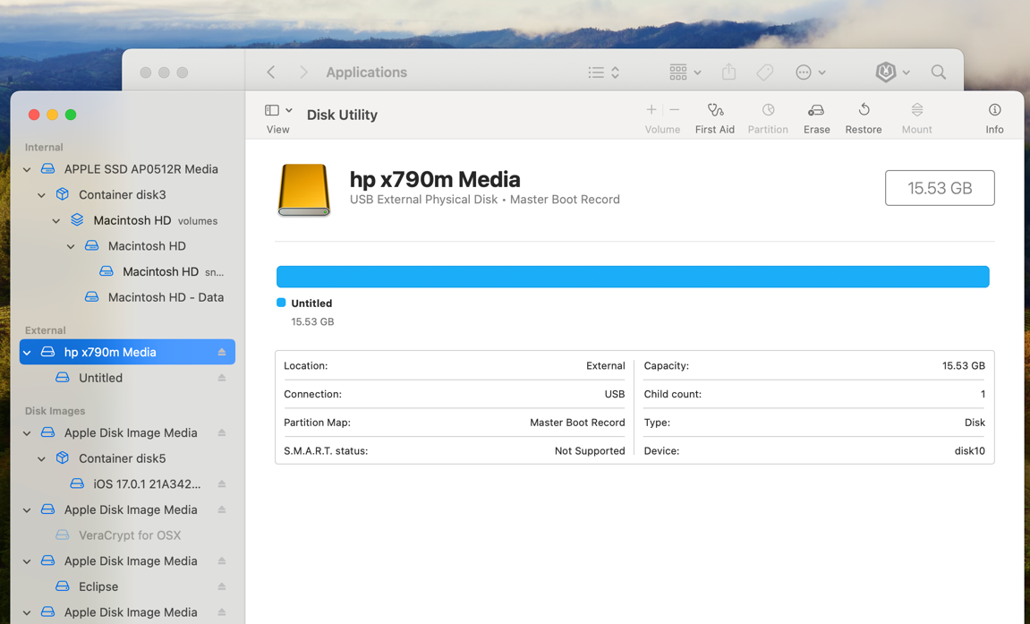

After this, click on the “erase” on the top of the window as seen in the screenshot. It will pop up another window and asking for some information.

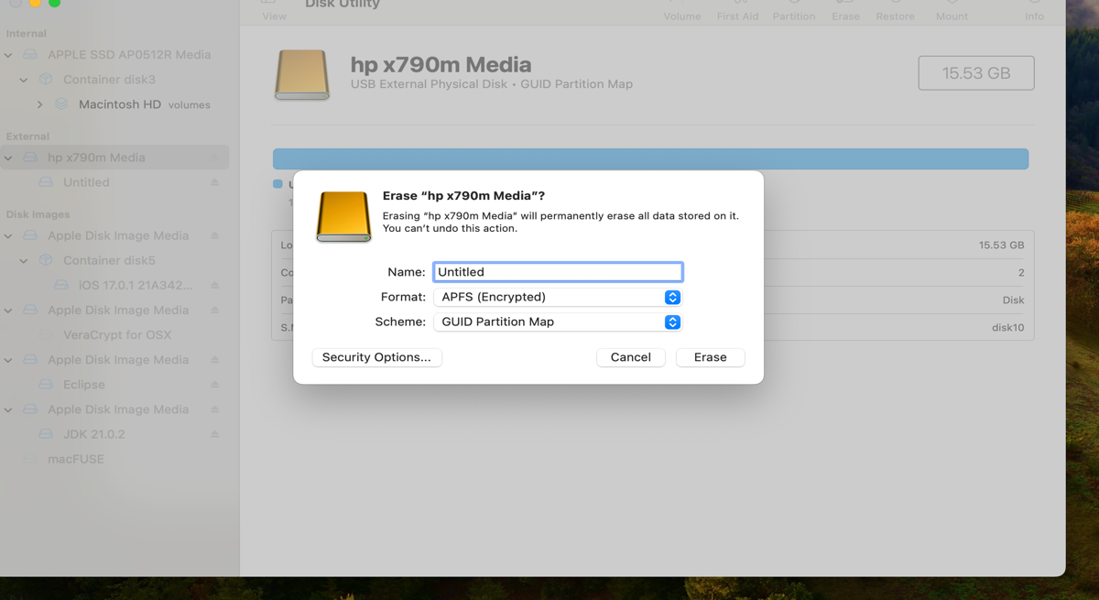

In this, we have to select “APFS(Encrypted)” in the format, and the Scheme should be “GUID PARTITION MAP.” And click erase.

After that, a new pop will open and will be asking for a Password.

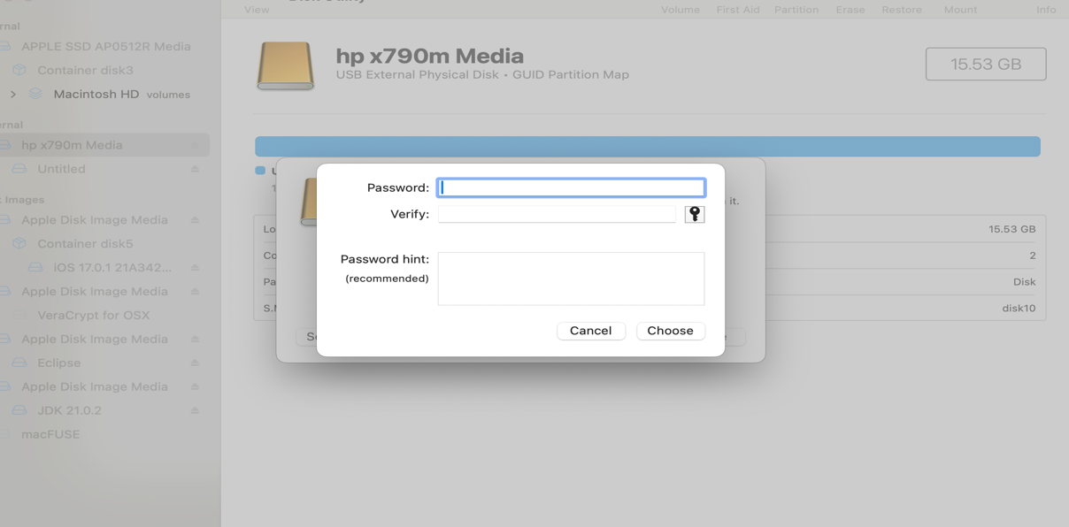

This password will allow you to open the USB drive and see the files.

After keeping the password for the USB drive, you can just click choose, and it will start unmounting the disk and creating the partition map.

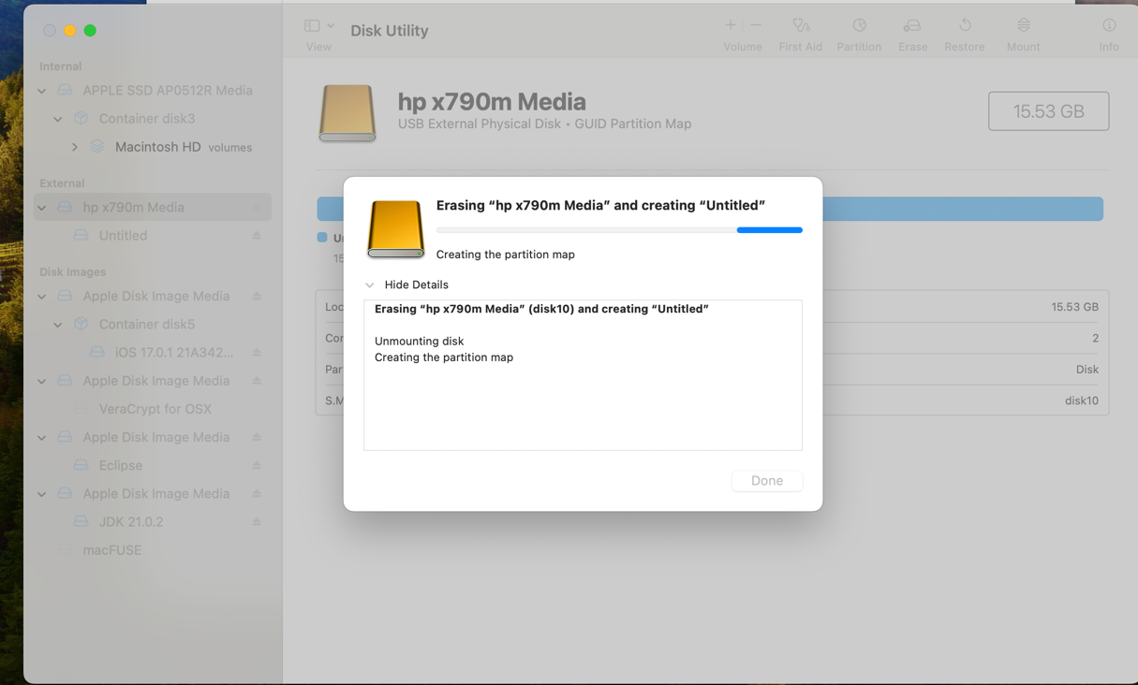

After the whole process is complete a new window will pop up which will show what have done with the USB drive.

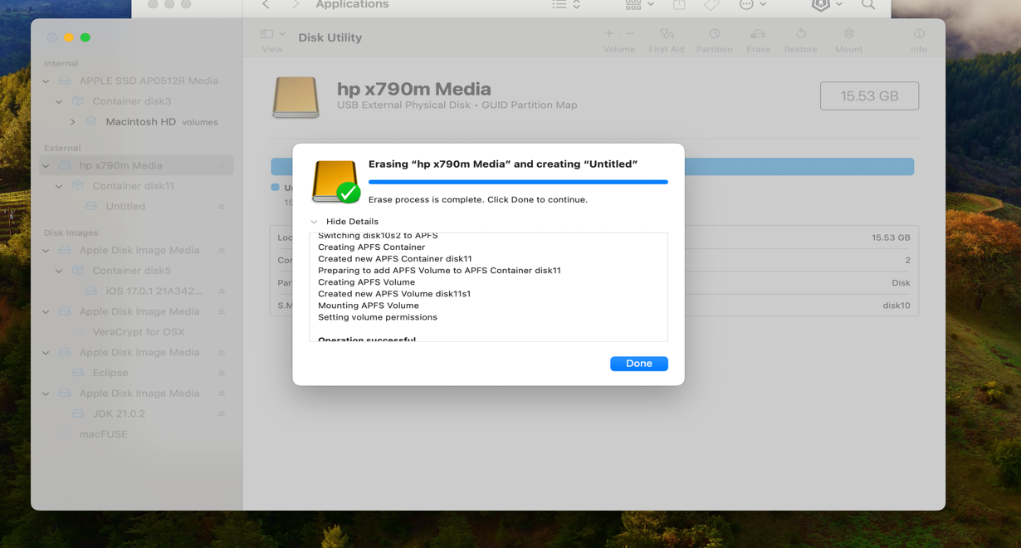

Now your USB drive is Encrypted, and whenever you want to use your drive, it will always ask for the password as you connect it to any computer. Anyone won’t be able to decrypt the USB drive with the password you have chosen.

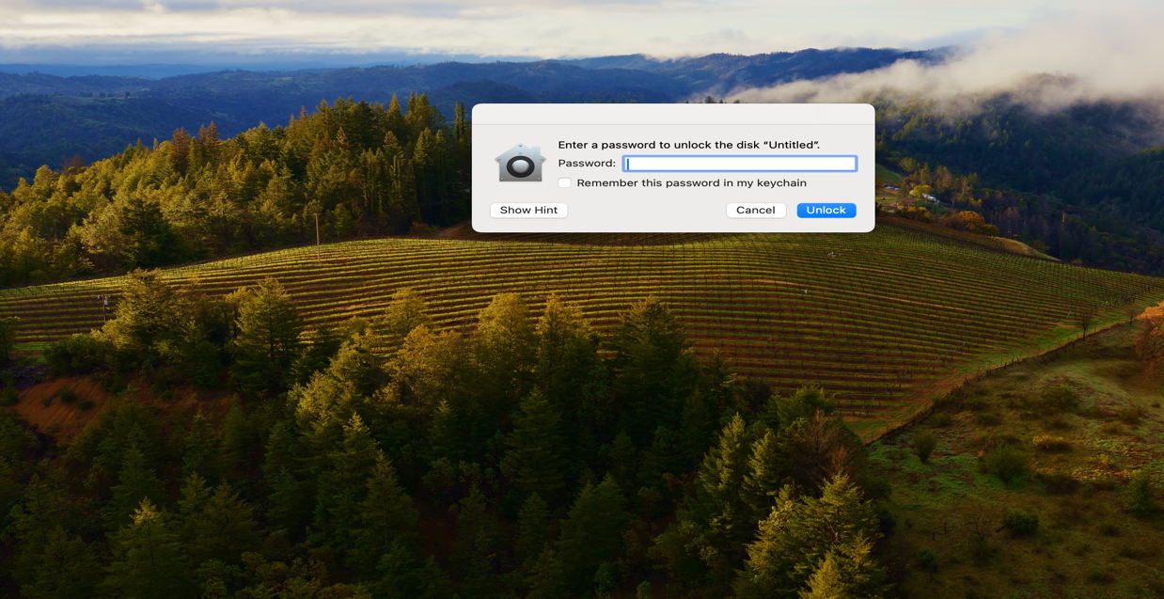

This Window will pop up as you connect the USB drive to the computer. The USB won't show up in the finder till you have entered the correct password.

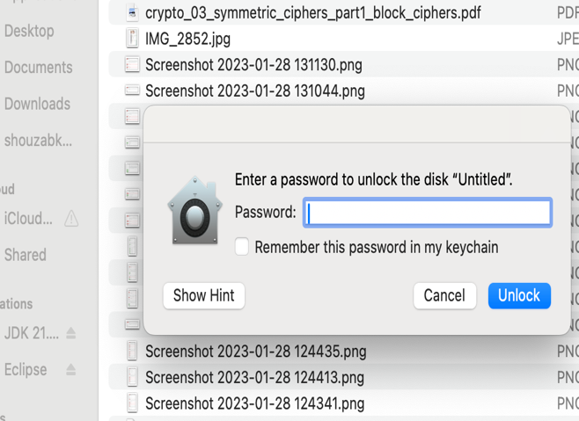 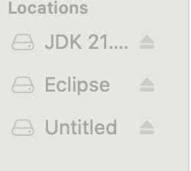

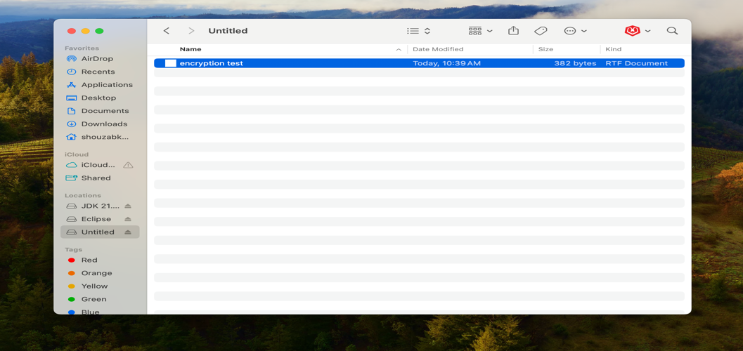

Now your USB drive is encrypted using the FileVault, so store the password in a safe place so that no one can get access to it.

**5. Detailed steps, including screenshots, for your experiments to encrypt the contents on a USB drive or an SD card using VeraCrypt.**

First, we have to download and install the VeraCrypt for Mac. When it's installed so, just open it and create a Volume.

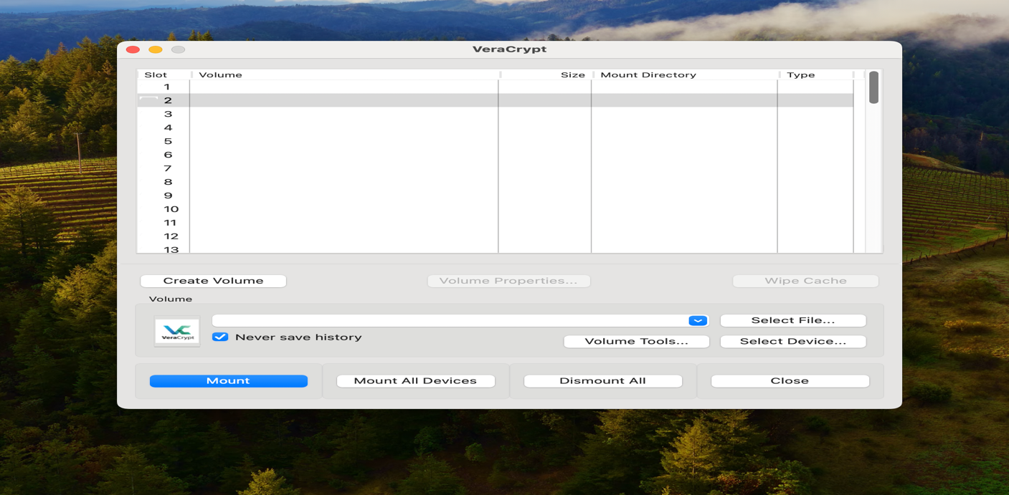

After that, a new window will pop up in which they will be asking, “Create an encrypted file container” and “Encrypt a non-system partition/drive.” I have to encrypt a USB drive, so we have to choose the 2nd option.

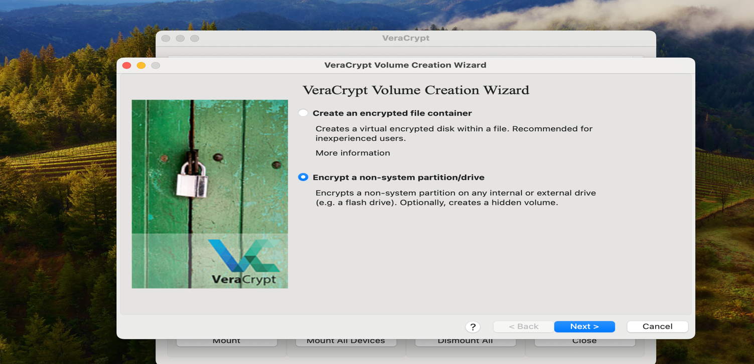

After clicking next, we have to choose the Volume type. So, there are two different types, “Standard VeraCrypt Volume” and “Hidden VeraCrypt Volume”. We have to choose the Standard one because we just need the normal one.

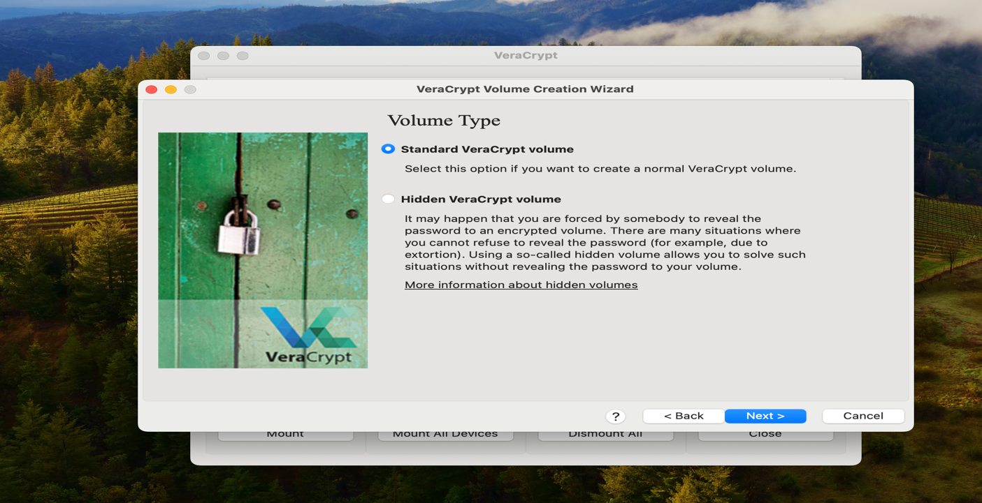

Now we have to Select the location/USB Drive which we have to Encrypt it so for that it will ask for the administrator rights.

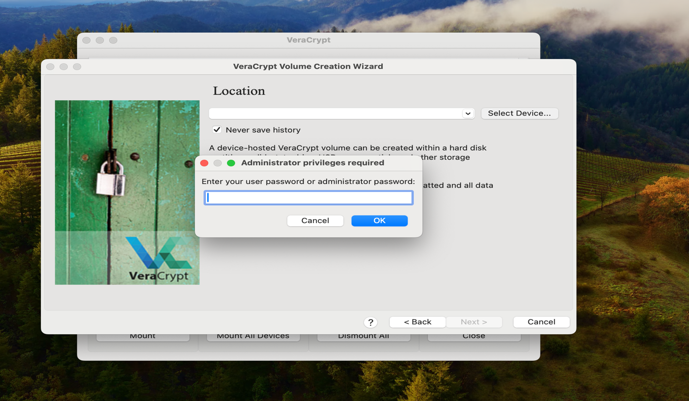

Now select the USB drive that will be Encrypted.

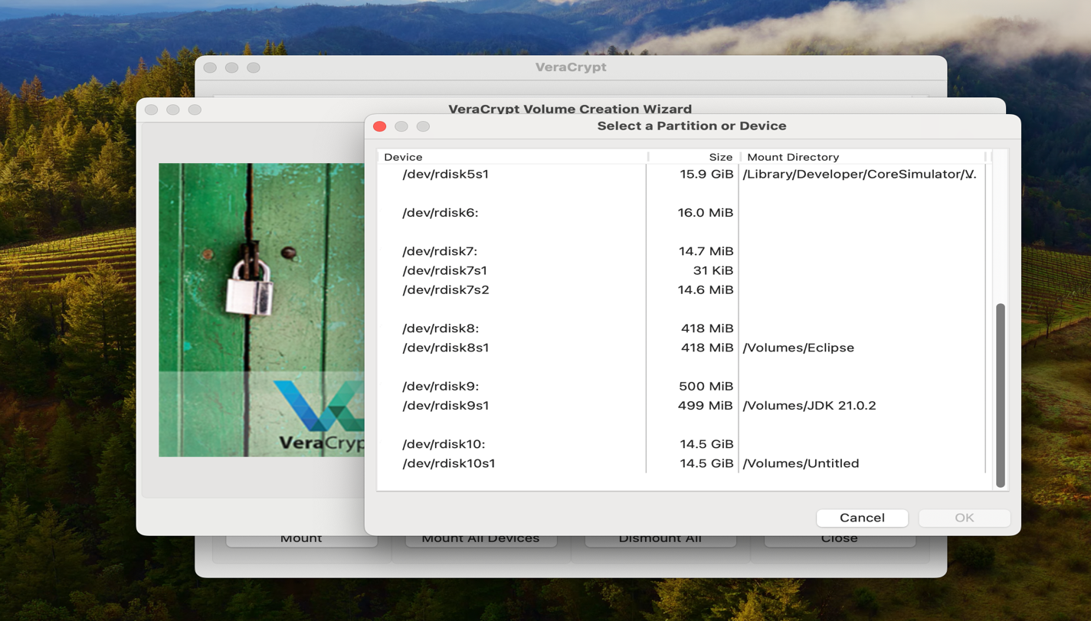

Now choose the Encryption Algorithm that will be AES, and Also the hash Algorithm that will depend on your USB drive and how fast it is. I will be using SHA-256 just because of the speed of the USB drive.

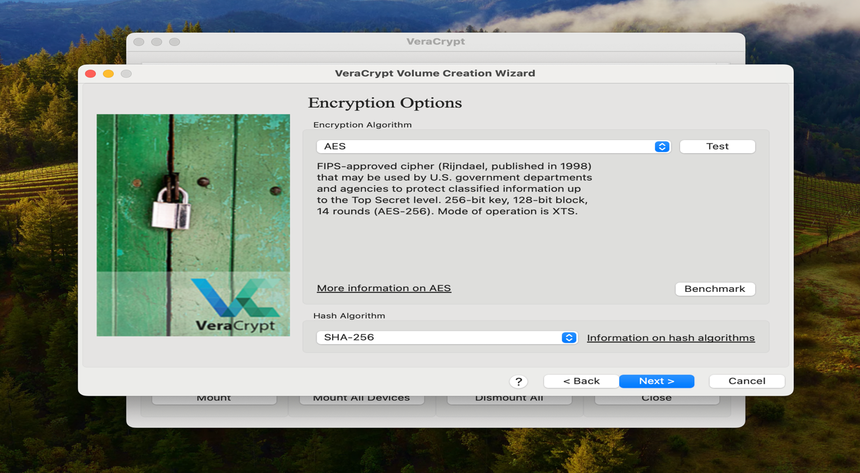

Now Choose the password, which will be kept for the Encrypted USB drive.

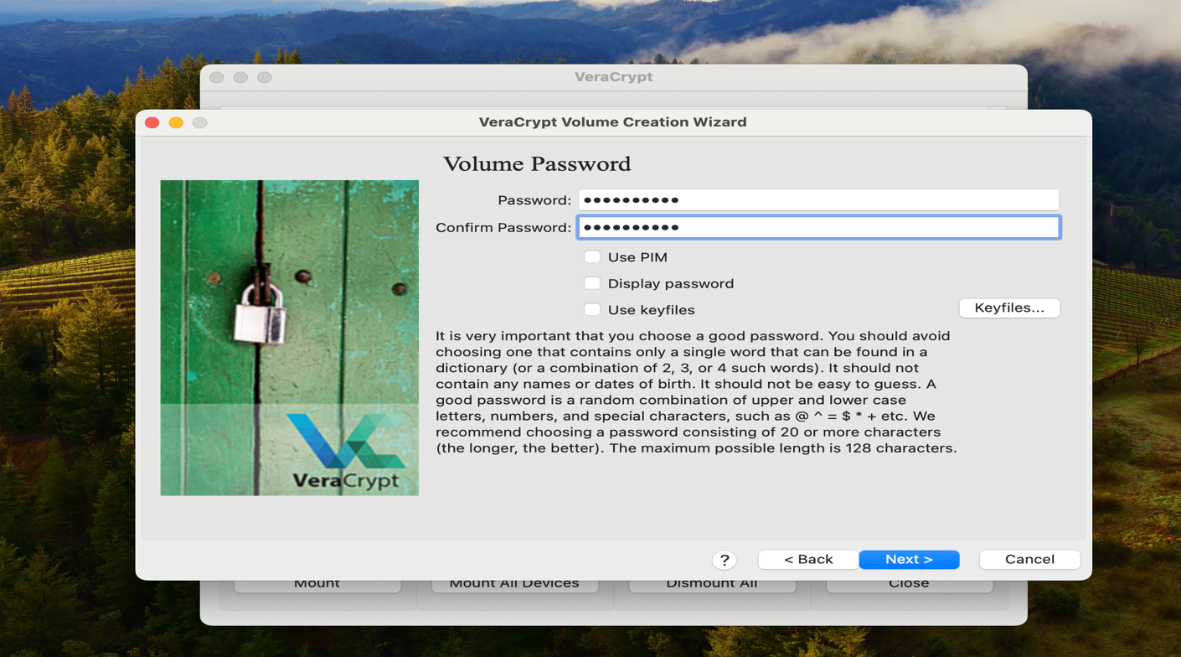

Now choose the Volume Format and that will be FAT.

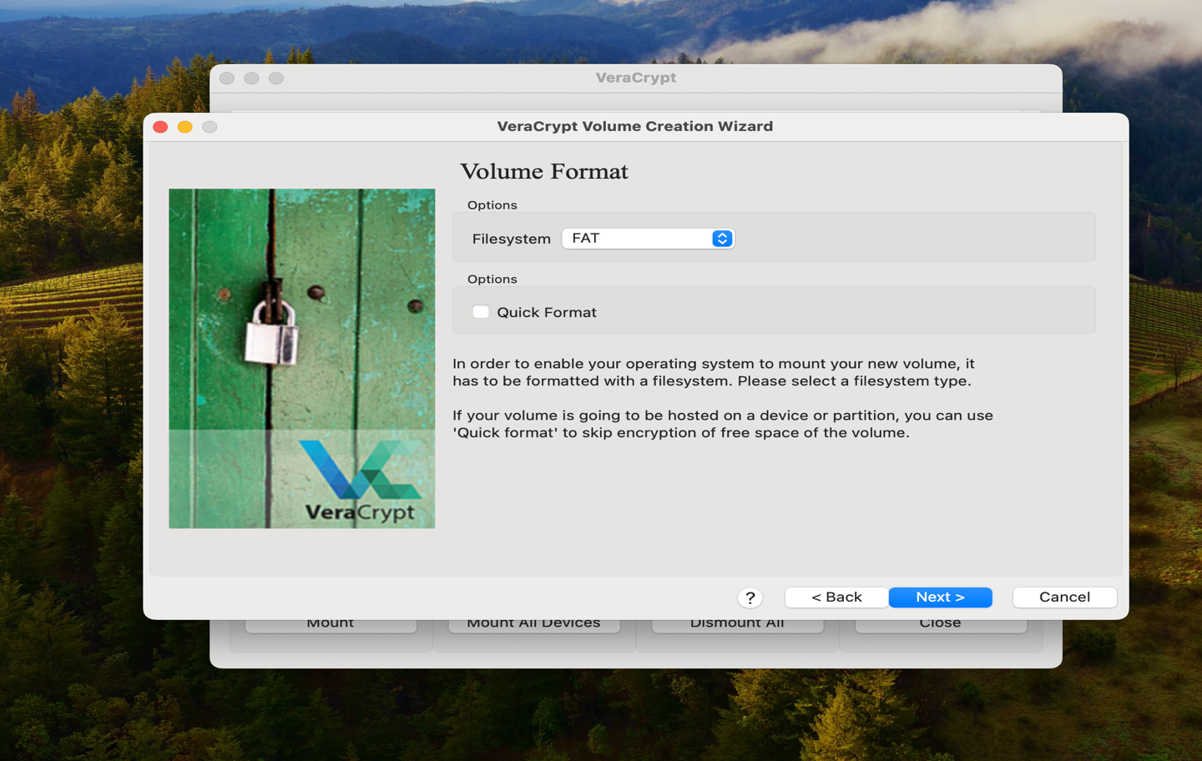

Now we have to Move your mouse randomly within the VeraCrypt window to generate randomness for the encryption key. After that click Format.

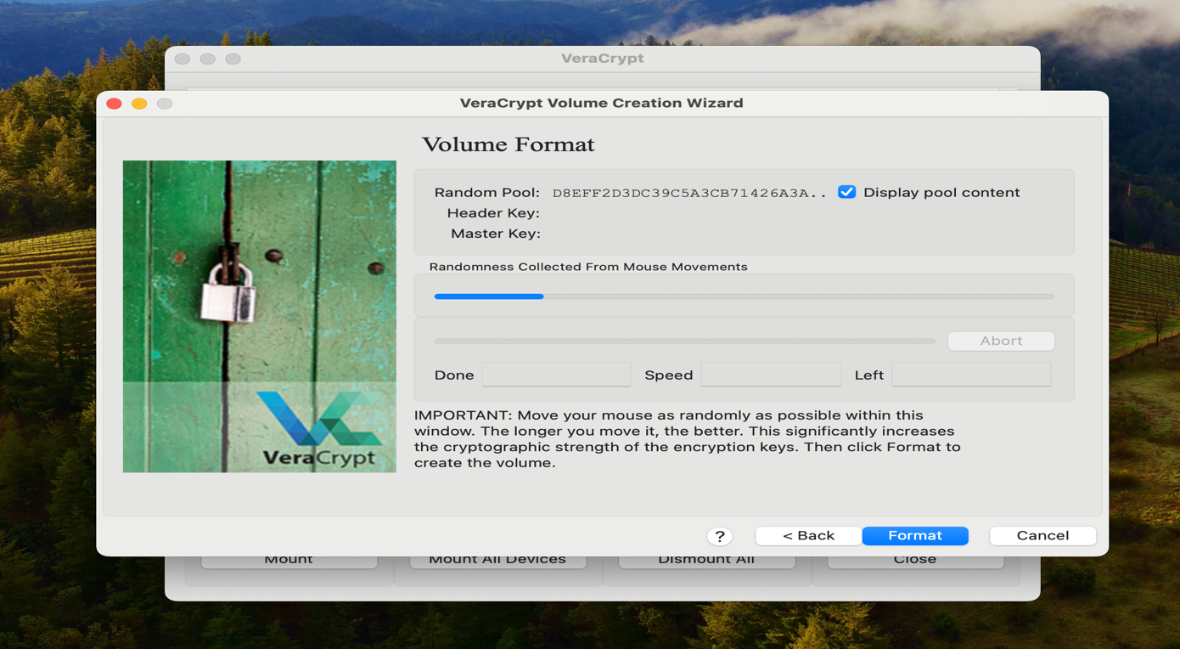

It will take some time to format the drive, but at last, a window will pop up, and it will say, and click ok.

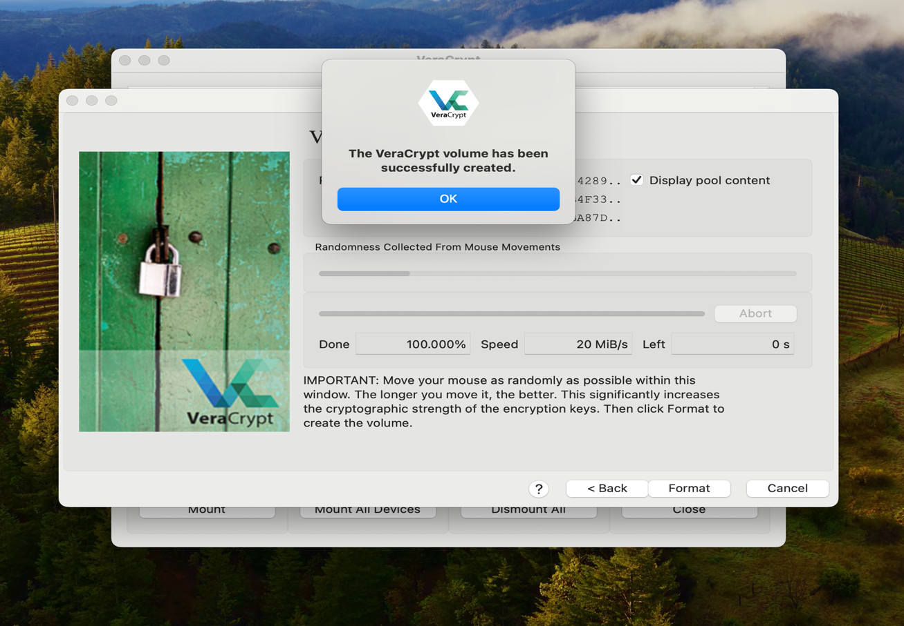

Now, for mounting the USB drive, click select device and choose the encrypted drive.

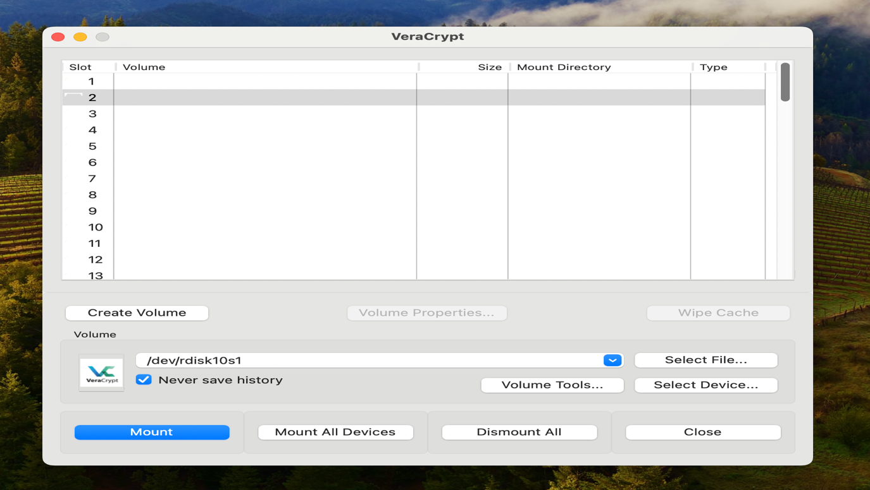

It will ask for the Password to open the encrypted drive.

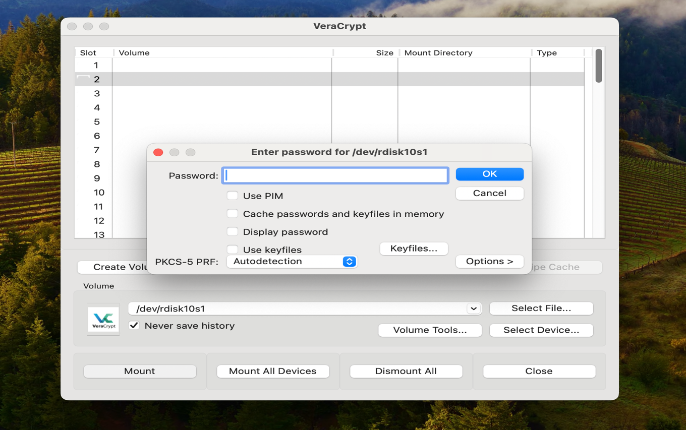

After entering the correct password, the computer will decrypt the USB drive, and it will be shown. Now you can add and delete the file in the drive.

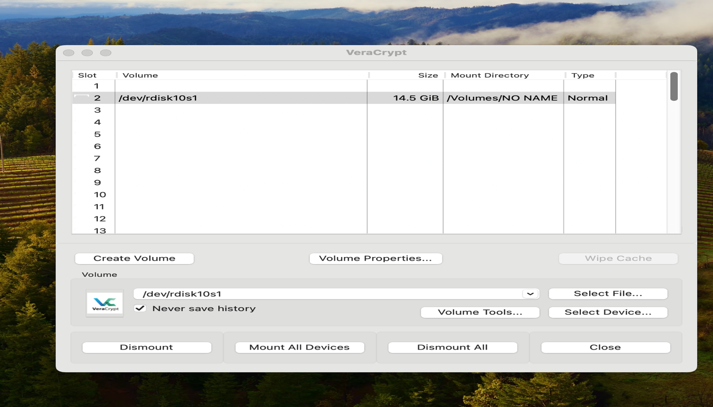

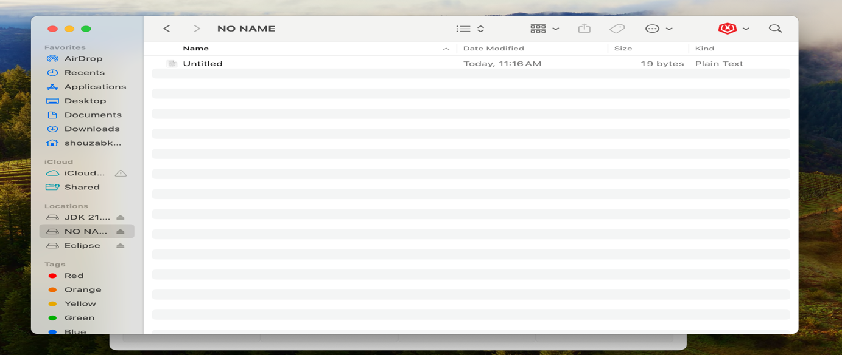

Now, after using the drive, you can just demount the drive, and it will hide. Now, just keep the password in a safe place so no one can find it.